**Did you know……?**

I post the newsletters on the homework site and the links are clickable- no typing in long address! Plus, check out the blog!

Fostering Independence

Here it is, almost November. We have learned to unpack our own bags, open most of your snack and lunch items and, most importantly, bathroom “stuff”.

What’s next you ask????? Can your child put on his own coat? If the answer is yes, then thumbs up for you- you get a sticker! If not, then start practicing. First of all, teach your child how to take the coat off without turning sleeves inside out, lol.

Second- have you seen the over the head trick? It works and the children think it’s fun. Here is a video demonstrating…..

<https://www.youtube.com/watch?v=mUaRSG6a3JU>

REMINDERS (and other things)

* **PLEASE make sure your child has a FULL set of clothes in his/her backpack!**
* Clearly label money and put it in your child’s folder.
* Put a note in your child’s folder if he/she is to purchase lunch.
* Buttons will go home with Brycen.
* Mary will go home with Ryan.

**Saint of the Week**

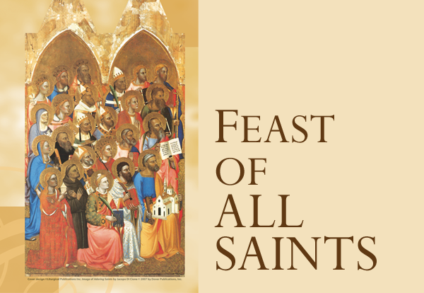

**Feast day 11/1**

**Holy Day of Obligation**

**Mass @ 9 AM**

***Parent Corner***

More ideas for independence in PreK……

<https://www.messforless.net/practicing-independence-skills-get-ready-for-k-through-play/>

<https://www.coffeecupsandcrayons.com/3-independent-skills-your-child-needs-for-kindergarten/>

<http://www.momto2poshlildivas.com/2013/06/everyday-ways-to-foster-independence.html>

Week of October 28, 2019

**Skills:**

**Math**- Count and write to 10, create patterns

**Language**- Letter “Gg”

**Story of the week**- Go Away, Big Green Monster

**Nursery Rhyme**- 1,2 buckle my shoe

**Cooking** (Thursday)- Spookley cookies

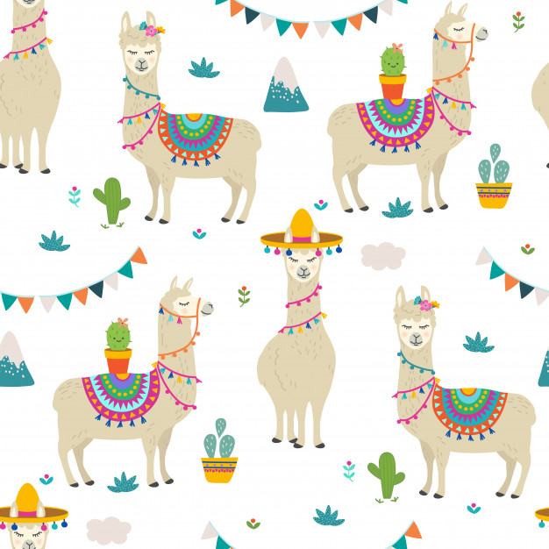

St. Philip Neri School

Mrs. Susan, Mrs. Heather

& Mrs. Anne

Pre K News

