**Saint of the Week**

**Our Lady of the Rosary**

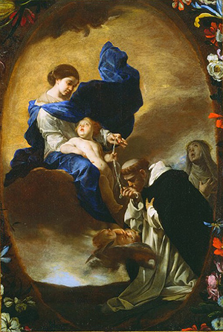

Feast day 10/7

<https://www.loyolapress.com/our-catholic-faith/saints/saints-stories-for-all-ages/our-lady-of-the-rosary>

REMINDERS (and other things)

This week-

* Buttons will go home with Asher.
* Mary will go home with Lauren.
* Field trip permission slips are here! Please return signed slips.
* Children should have a full change of clothes in their back packs- underwear, pants, socks and shirt.
* Please put any money inside your child’s white folder.
* We ask that morning snack be healthy- please no candy!

***Parent Corner***

For more math fun, check out:

<https://www.naeyc.org/our-work/families/5-ways-build-math-your-childs-day>

<https://www.naeyc.org/our-work/families/things-know-about-math>

<https://www.naeyc.org/our-work/families/help-child-see-math>

Developing Number Sense

Numbers are more than just counting by rote. To truly begin to understand math, children must begin to recognize quantity without counting one by one- this is called subatizing (like how we know a die shows 3 dots without counting them). One strategy we use is to arrange items on a frame of five or ten squares. When children begin to look at quantity rather than just identifying a numeral, they begin to develop “number sense”- it is a deeper understanding of math.

For additional information and free printable dot cards to use at home, please visit <https://www.pre-kpages.com/developing-number-sense-in-preschool/> .

Week of October 7, 2019

**Skills:**

**Math**- Count and write to 7

**Language**- Letter “Aa”

**Writing/Fine motor**- Writing names, draw a person

**Bible Story**- Tower of Babel

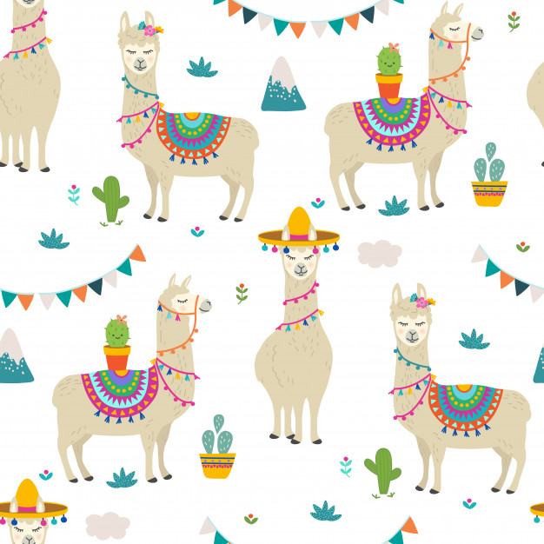

St. Philip Neri School

Mrs. Susan, Mrs. Heather

& Mrs. Anne

Pre K News

