***Parent Corner***

Afterschool meltdowns are REAL- here is a great article- <https://www.todaysparent.com/kids/school-age/after-school-restraint-collapse-is-a-real-thing-heres-how-to-deal-with-it/>

Want to see a correct pencil grip in action?

<https://youtu.be/gZO26RwEyiU>

This dish was a life saver when my kids were younger- make ahead to reheat or freeze-

<https://www.eatingonadime.com/spaghetti-pie-recipe/>

**Saint of the Week**

St. Matthew



Feast day 9/21

REMINDERS (and other things)

This week-

* Buttons will go home with Alexa.
* Mary will go home with Joel.
* We will be meeting our 7th grade Buddies and visiting the Church. Our first Mass will be on September 23.

Week of September 16, 2019

**Skills:**

**Math**- Count and write to 5

**Language**- Letter “Oo”, Little Miss Muffet

**Writing/Fine motor**- Pencil grip, using scissors

**Bible Story**- Creation

**Improving Pencil Grip**

There are lots of easy little tricks OTs like to use to promote stronger, more effective grasp patterns on writing utensils. Here are some favorites:

1. Work on building strong core muscles and balance.

2. If your child holds the pencil too high or too low, put a sticker or some tape in the right spot.

3. Try shorter pencils or broken crayons. This will help your child naturally grasp at the correct height.

4. Practice writing on an easel or slanted surface.

To read the full article, please visit

<https://theinspiredtreehouse.com/fun-writing-prompts-for-kids-the-pen-pal-project-week-2/>

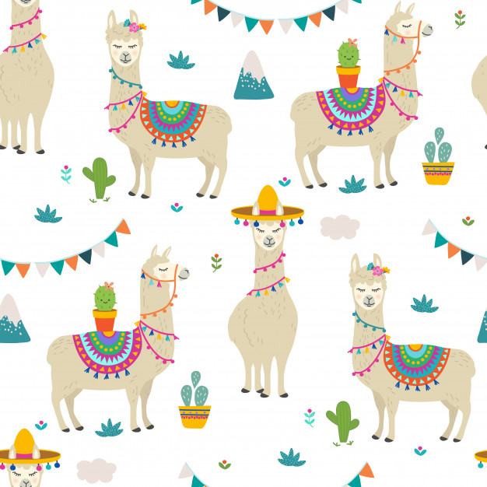

St. Philip Neri School

Mrs. Susan, Mrs. Heather

& Mrs. Anne

Pre K News

