**Why Say Nursery Rhymes?**

Nursery rhymes date as far back as the Middle Ages, but are still learned by many young children today. Nursery rhymes are more than just cute poems- they teach a great deal about language and can help children become better readers.

Reciting rhymes teaches vocabulary, pitch, rhythm, speech and even motor skills.

If you are out of practice with nursery rhymes, you can search on youtube or visit [https://www.nurseryrhymes.org](https://www.nurseryrhymes.org/) for a complete list.

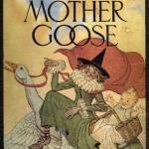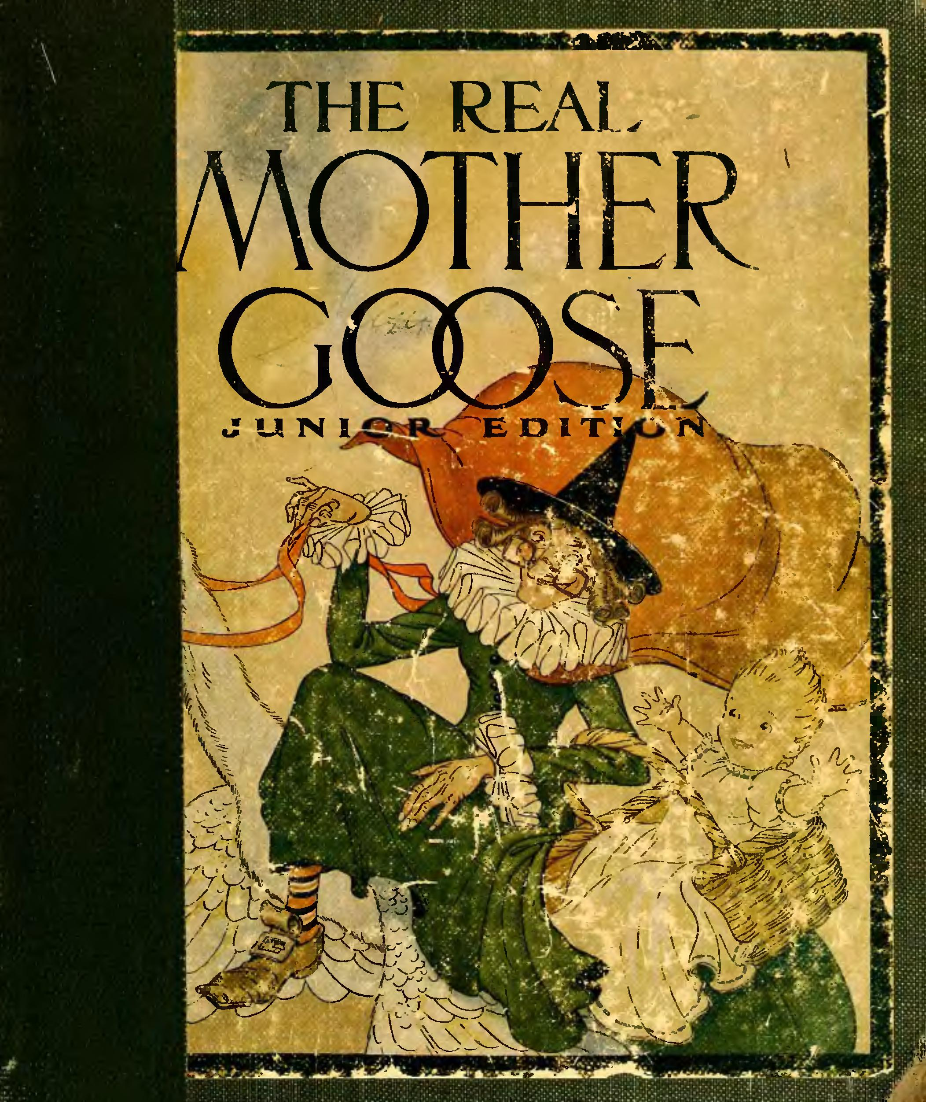

REMINDERS (and other things)

This week-

* Buttons will go home with Alexa.
* Mary will go home with Jude.
* Friday, Sept. 27, will be APPLE DAY!!!

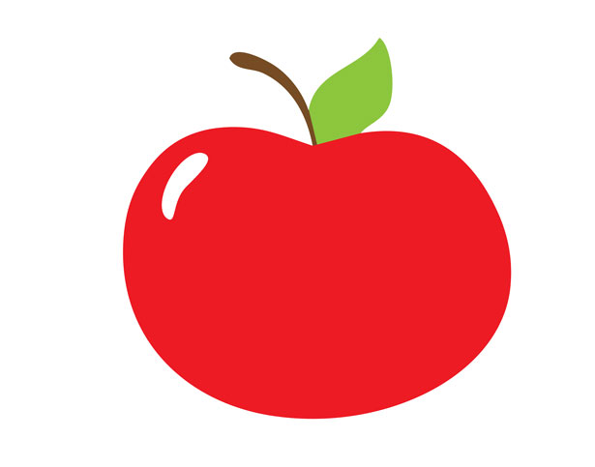

***Parent Corner***

For more information about Nursery Rhymes-<https://pambarnhill.com/nursery-rhyme-benefits/>

<https://www.poetryfoundation.org/poets/mother-goose>

Need scissor practice?

<https://www.parents.com/toddlers-preschoolers/development/physical/teaching-preschoolers-to-use-scissors/>

What to do with all those apples?

<https://www.thechunkychef.com/old-fashioned-easy-apple-crisp/>

**Saint of the Week**

[St. Padre Pio](https://www.catholic.org/saints/saint.php?saint_id=311)

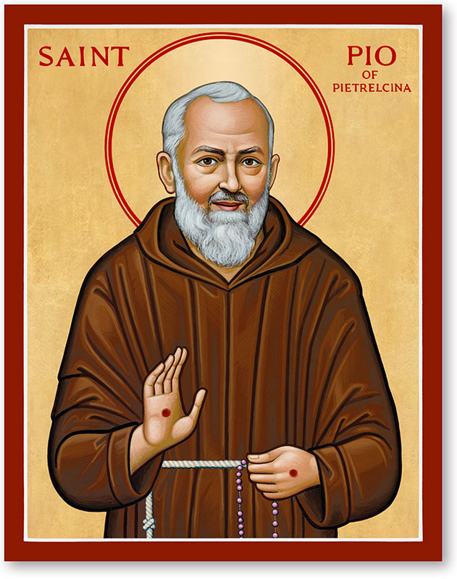

Feast day 9/23

Week of September 30, 2019

**Skills:**

**Math**- Count and write to 5

**Language**- Letter “Tt”, five senses

**Writing/Fine motor**- Pencil grip, using scissors

**Bible Story**- Noah’s Ark

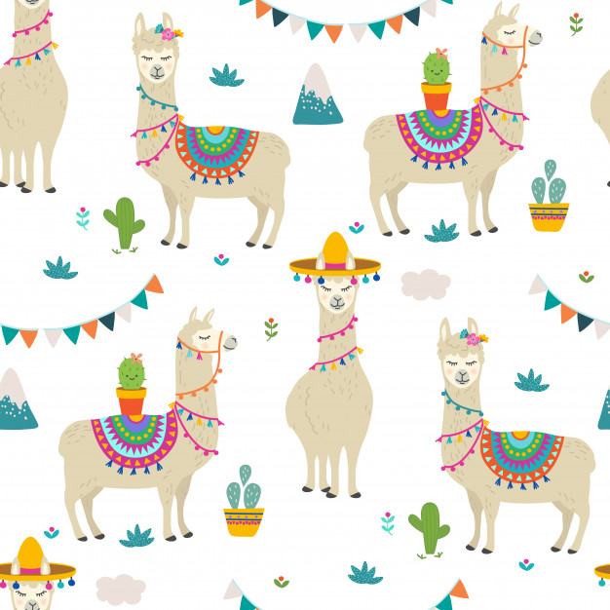

St. Philip Neri School

Mrs. Susan, Mrs. Heather

& Mrs. Anne

Pre K News

