Week of Jan. 27, 2020

Weekly Focus:

|  |  |
| --- | --- |
| Color- purple | Shape- square |
| Letter- Dd | Number- 12 |
| Sight words- you is | Rhyme- I’m a Little Penguin |
| Story- Tacky the Penguin series | |
|  | |

***Parent Corner***

<https://www.naeyc.org/resources/pubs/yc/may2019/outdoor-play-is-essential>

<http://movingsmartblog.blogspot.com/2011/05/m-is-for-monkeybars-getting-ready-for.html>

Announcements

* Buttons will go home with Ethan-Cole. Mary will go home with Sloane.
* Happy Birthday to Grace, Riley and Caleb!

Dear families,

We are a month into the New Year, and with Mrs. Susan being away followed by a long holiday break, we felt this was a good time to get back into routines. Please remember the following when packing your child for the day:

Put ALL snack in a separate LABELED zipper bag…. Some of the children are not sure what is snack and what is lunch, and often we have had children thinking someone else’s snack was theirs.

We go outside every day, unless it is raining or below freezing. Please make sure your child has the appropriate coat, hat and gloves to play outside.

If your child is going to be absent, please call the school nurse, Mrs. Brandi to let her know.

Sneakers are the “uniform” shoe for pre K. Please, no boots or slipper style shoes.

**Saint of the Week**

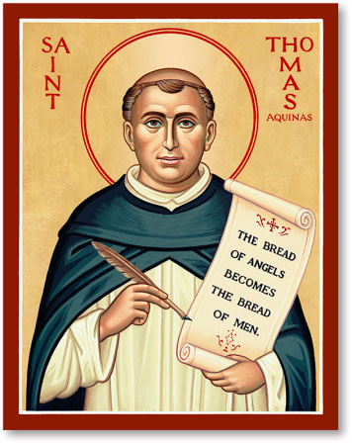

St. Thomas Aquinas

Feast Day- Jan. 28

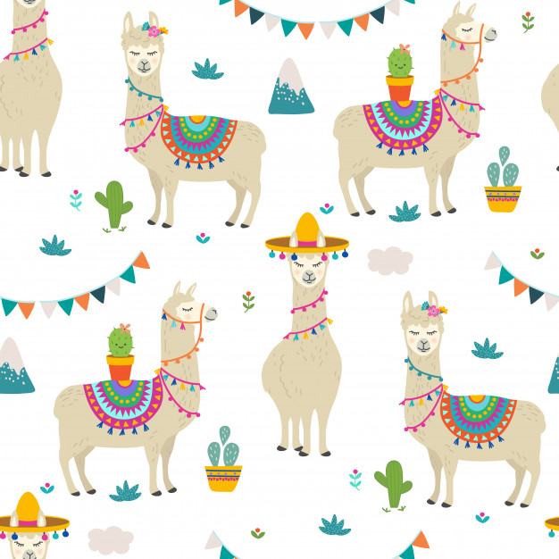

St. Philip Neri School

Mrs. Susan, Mrs. Heather

& Mrs. Anne

Pre K News

