***Parent Corner***

**Gratitude Links**

<https://www.merakilane.com/teach-child-gratitude-gratitude-activities-kids/>

<http://www.momentsaday.com/activities-to-teach-gratitude/>

<https://www.youtube.com/playlist?list=PLc1msHr32JwQrmMpFlRCOOLS44N19fVRN>

Season of Grateful…..

It’s that time of year. Everyone is posting 30 days of “grateful” for November. It is nice to be grateful, but shouldn’t we be thankful the remaining 335 days of the year? More importantly, we should model that mindset for our children.

How do you TEACH gratitude? It is a very abstract concept, but there are ways to develop a sense of thankfulness in very young children.

Here are some ideas to get you started…

1. Tell what YOU are grateful for.
2. Write (or draw) thank you cards.
3. Ask “how would you feel without (fill in the blank)?”
4. Read books about thankfulness
5. Make a list.

Four to five year olds can express gratitude through talking, drawing pictures, etc. Encourage them to let others know how special they are to them. They just might surprise you!

Week of Nov. 18, 2019

Weekly Focus:

|  |  |
| --- | --- |
| Color- blue | Shape- square |
| Letter- Mm | Number- 6 |
| Sight words- I up see | Rhyme- Humpty Dumpty |
| Story- Give Thanks to the Lord | |
|  | |

**Saint of the Week**

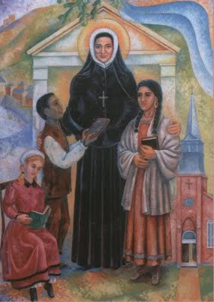

St. Rose Philippine Duchesne

Feast Day- Nov. 18

REMINDERS (and other things)

* Buttons will go home with Cameron.
* Mary will go home with Sloane.
* **$5 for Charlie Brown Thanksgiving is due 11/22**



St. Philip Neri School

Mrs. Susan, Mrs. Heather

& Mrs. Anne

Pre K News

