Buttons has become a bit of a class mascot (yes, we know he is NOT a llama). Every week a student will get to bring home Buttons for a fun visit. He will come with a journal to be used for sharing your adventures and we LOVE to see pictures, too. Over the years Buttons has been in a wedding, visited Ocean City, gotten “haircuts” and had his “teeth” cleaned. We have saved his journals and some of his oldest friends are in the 8th grade now! We know you will be SO EXCITED to see him come to your house soon.

Some of

REMINDERS (and other things)

* Pack snacks in a labeled Zipper bag. It is easier for the children to unpack if you put the bag inside the backpack instead of the lunchbox.
* Please return the white folder every day.
* Return the Thursday envelope on Friday.
* **READ** to your child every day!!!!!

Parent Corner

Check out these great websites!

For rhyming- <https://www.prekinders.com/rhyme/>

For counting- <https://justifyingplaybased.weebly.com/11-correspondence.html>



Meet Buttons!

Week of September 9, 2019

Skills:

**Math**- Counting one to one up to 5

**Language**- Rhyming, Names

**Writing/Fine motor**- Holding pencils, using glue, and cutting with scissors

**Social**- Friends

**Science**- Why we wash our hands!

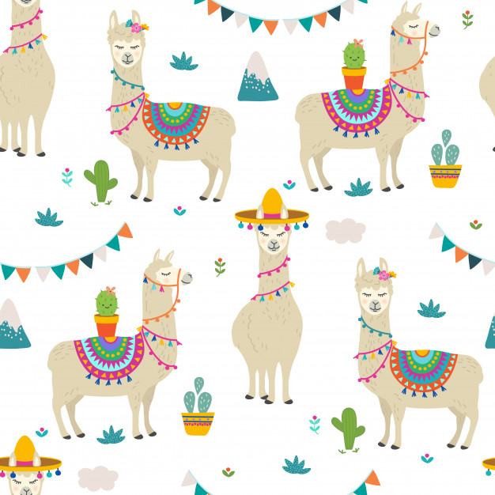

St. Philip Neri School

Mrs. Susan, Mrs. Heather

& Mrs. Anne

Pre K News

